Modeling Tool Design
Version: | 1.1rc
Author(s): | JE, JS
Created: | 04/20/2009
Last modification: | 09/18/2009

Version | Date | Author(s) | Changes
1.0 | 05/18/2009 | JE, JS | Initial version.
Contents
1. The Client Side Modeling Tool – View Elements 4
1.1. Overview 4
1.2. Workflow, Nodes and Containers 4
1.2.1. Common attributes: 5
1.2.2. The Workflow class: 5
1.2.3. The Node Class: 5
1.3. Node Selection and Resizing 6
1.3.1. The SelectionHandler Class 6
1.3.2. The NodeSelectionBox Class 6
1.3.3. The DragBox Class 7
1.3.4. The ResizeDragController Class 7
1.4. Connections 7
1.4.1. The Connection Interface 7
1.4.2. The Connection Class 8
1.4.3. The OrthogonalConnection Class 8
1.4.4. The ConnectionDragController Class 8
1.5. Ports 8
1.5.1. The abstract Port Class 8
1.5.2. InputPort and OutputPort 8
1.5.3. ContainerStartPort and ContainerExitPort 9
1.6. The DndRegistry 9
2. The Model Classes 10
2.1. Workflow, Node and Connection Model 10
2.1.1. The Model Interface 10
2.1.2. The HasChildModels Interface 10
2.1.3. The WorkflowModel Class 11
2.1.4. The Variable Class 11
2.1.5. The NodeModel Class 11
2.1.6. The NodePropertyData Class 11
2.1.7. The ConnectionModel Class 11
2.1.8. ContainerStartConnection and ContainerExitConnection 11
2.1.9. The Condition Class 11
2.2. InvokeNode Models 12
2.2.1. The EmailInvokeNodeModel Class 12
2.2.2. The HumanTaskInvokeNodeModel Class 12
2.3. Container Models 13
2.3.1. The ContainerModel Class 13
2.3.2. The FlowContainerModel Class 13
2.3.3. The ForEachContainerModel Class 13
2.3.4. The IfContainerModel Class 13
3. Dialogs 14
3.1. Overview 14
3.2. The Dialog Registry 14
3.2.1. Methods 14
3.2.2. Invoker classes 14
3.3. Variable Editor 15
3.4. Property Windows 15
4. Commands 15
4.1. The Command Stack 16
4.2. Commands 16
4.2.1. The UndoableCommand Interface 16
4.2.2. The Command Classes 16
4.2.3. The UndoableCommand Classes 17
5. External Interfaces 18
5.1. Loading and Storing the DWDL 18
5.2. Embedding in the Web Portal 18

The Client Side Modeling Tool – View Elements

Overview
This chapter describes all the classes which are relevant for the graphical issues of the modeling tool. The view elements are based on the Google Web Toolkit (GWT), for drag & drop functionality, the drag & drop library gwt-dnd is used.

Workflow, Nodes and Containers
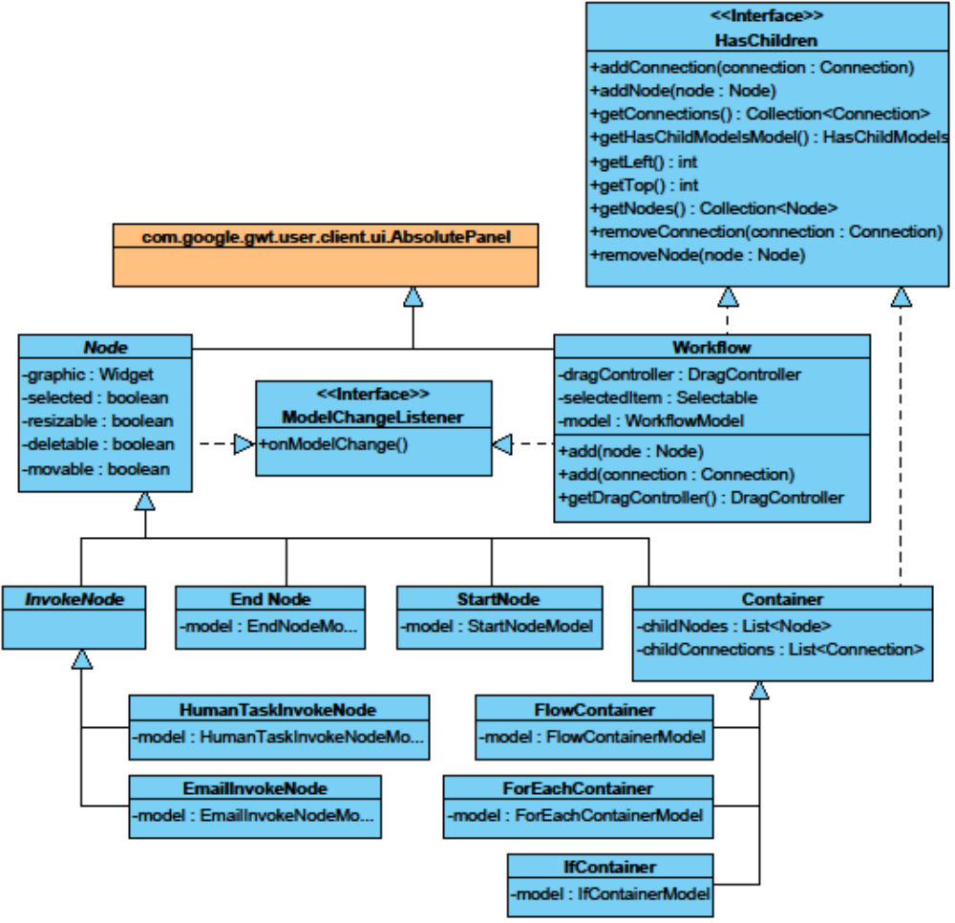
Figure 1: Class diagram of the workflow, nodes and containers.

Common attributes:
model:
Each non-abstract node class and the workflow class have a model which holds the data of the node/workflow (see chapter Error: Reference source not found). All these classes implement the ModelChangeListener interface. The containing method onModelChange() is called by the model class when any data changes. The getter is required to access the model data.

The Workflow class:
This is the main class of the graphical workflow and also the drawing canvas. This class is a singleton and its object is embedded in the Modeling Tool website.

nodes:
A list of all nodes in the workflow not included by a container. Nodes within a container are accessed through its parent container node.
Connections:
A list of all connections in the workfloe not included by a container. Connections within a container are accessed through its parent container node.

The Node Class:
This class is the graphical representation of all nodes (including containers). It holds all graphical relevant properties of a node and is the receiver of user interactions with that node.
graphic:
The graphical representation of the node.
selected:
True, if the node is the selected node. If this value is true, the selectedItem attribute of the workflow must point to this node.
movable:
True, if the node is movable. If this value is true, this node is made draggable during adding to a workflow, else not.
resizable:
True, of the node is resizable (see chapter 1.3).
deletable:
True, if the node can be deleted.

Node Selection and Resizing
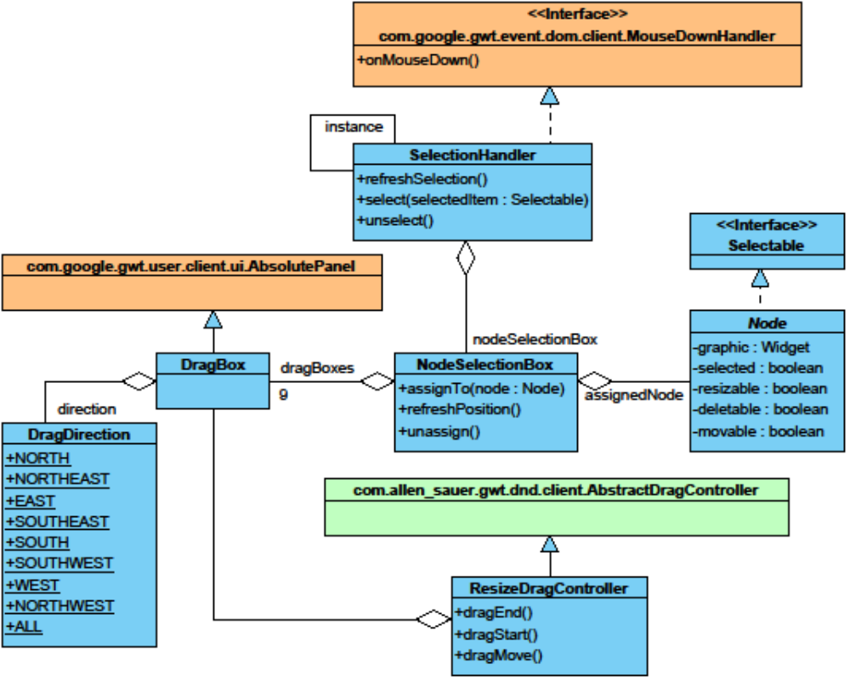
Figure 2: Class diagram of the node selection and resizing classes.

The SelectionHandler Class
This class handles the selection of items in the workflow and manages the graphical representation of the selection state. It also holds the currently selected item.
selectedItem:
The selected item (of type Selectable) in the workflow. This can be only one widget. Null, if no widget is selected.
The Selectable Interface
isSelected() / getSelected():
This interface has only two methods to read and write the selected state of the implementing class. The implementing class has to care about the graphical selection representation (SelectionBox) and selection events, e.g. per mouse click.

The NodeSelectionBox Class
This class is for representing the selected state of the assigned node. It contains 9 dragBoxes (see 1.3.3) surrounding the graphical object of the node which can be used to resize the node, if allowed. The dragController (of type ResizeDragController) makes the DragBoxes draggable to make the node resizable. There’s only one drag controller for all 9 DragBoxes.

The DragBox Class
A DragBox object is a little colored square box which is intended to mark the currently selected node and act as drag handle for resizing (if allowed). It is associated with a DragController (of type ResizeDragController)which controls the resizing operation, and a DragDirection which declares the Position of the dragBox in the NodeSelectionBox and the allowed resize direction. The DragDirection is set by constructor.

The ResizeDragController Class
This class is responsible for resizing a node by its 9 dragBoxes. It has to care for making the dragBoxes draggable, changing the selected node’s size when dragged and performing a ResizeNodeCommand (see 5.2).

Connections
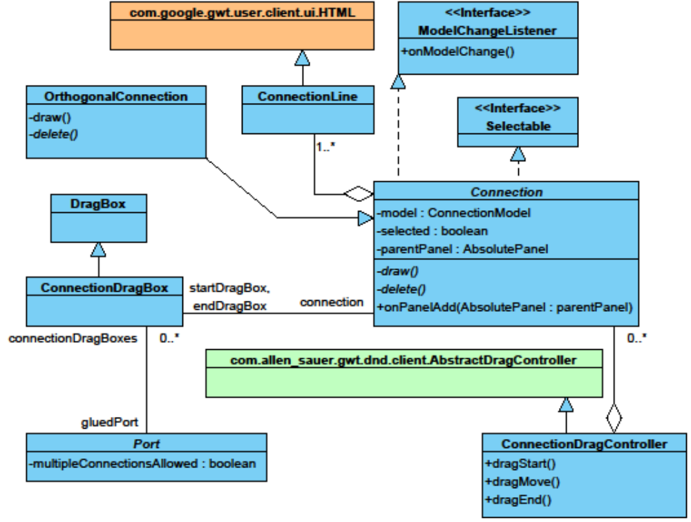
Figure 3: Class diagram of the connection and connection drag classes.

The Connection Interface
This interface is implemented by all connections. The draw() operation redraws the connection line during moving/creation of connections or nodes with associated connections. The getModel() function returns the data model object of the connection.

The Connection Class
This class is a complete connection class except draw and delete methods. These have to be implemented by subclasses which have their own drawing/line style, like the OrthogonalConnection class.

The OrthogonalConnection Class
This class inherits the Connection class and adds orthogonal line style.

The ConnectionDragController Class
The ConnectionDragController makes the end points of the connection draggable and is associated with the PortDropControllers (see 1.5) of the ports which are allowed to connect to.

Ports
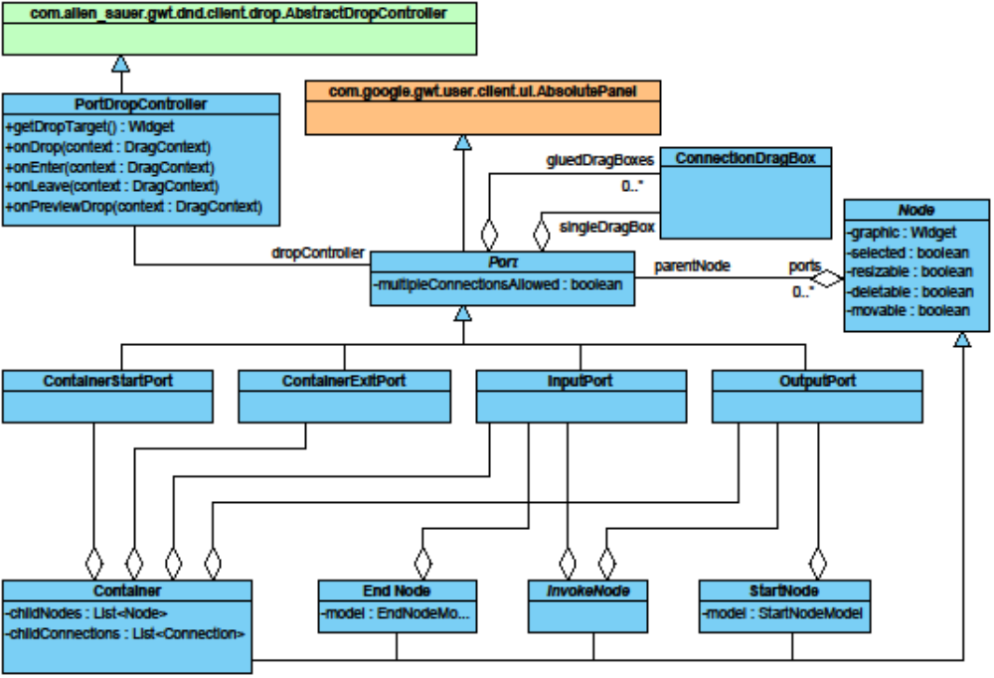
Figure 4: Class diagram of the port classes.

The abstract Port Class
This abstract class is a complete (untyped) port class except of the dropController. The dropController has to be instantiated by the subclasses because every subclass has to specify its own connection rules.

InputPort and OutputPort
The InputPort and OutputPort classes are the standard port classes for every Node and are used to connect the nodes to each other by connections. Each Node owns one InputPort and one outputPort except the EndNode (only InputPort) and the StartNode (only OutputPort) class.

ContainerStartPort and ContainerExitPort
Every Container class has one ContainerStartPort and one ContainerExitPort within its container area. These two ports are the start and exit point for the nodes owned by the container.

The DndRegistry
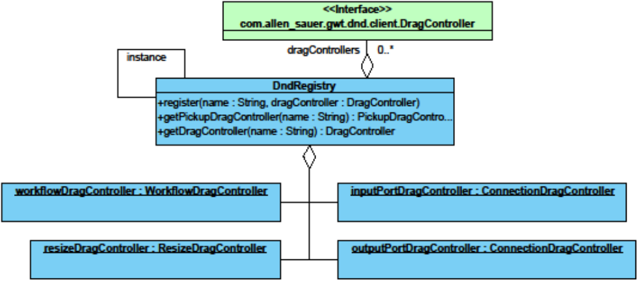
Figure 5: DndRegistry class and registered objects
workflowDragController:
A simple drag controller that makes all movable elements draggable to any location within the workflow panel. Every element added to the workflow has to be made draggable separately.
resizeDragController:
The resize drag controller for resizing nodes, see 1.4.4.
inputPortDragController
The drop controllers of all input (container exit) ports are assigned to that drag controller. So drag boxes made draggable by this drag controller can be dropped on input (container exit) ports.
outputPortDragController:
The drop controllers of all output (container start) ports are assigned to that drag controller. So drag boxes made draggable by this drag controller can be dropped on output (conainer start) ports.

The Model Classes

Workflow, Node and Connection Model
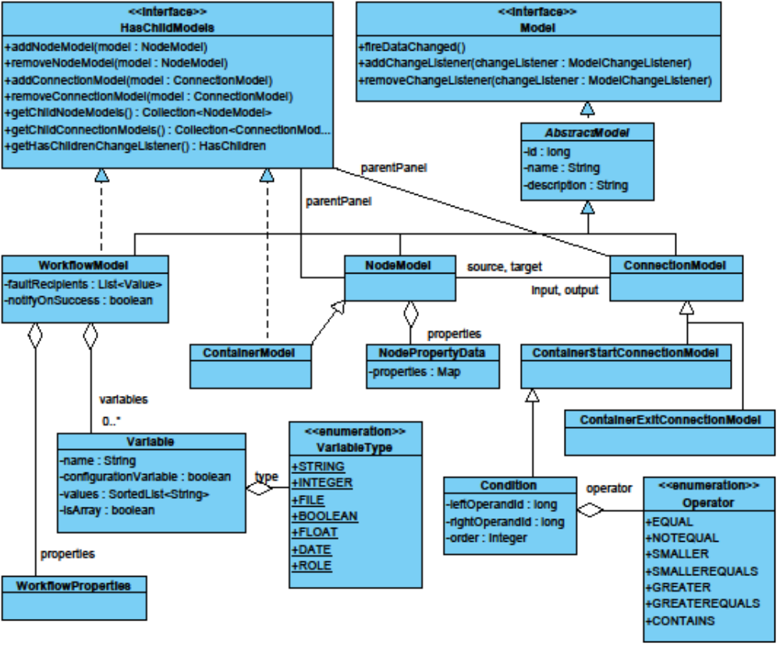
Figure 7: Class diagram of the three main models.

    - The Model Interface
This interface is implemented by every model class and adds listener operations, so any class which implements the ModelChangeListener class can be added as to a Model as a listener. If any data in the Model changes, the fireDataChanged operation has to be executed so all listening classes are notified.
The AbstractModel Class
This class implements the listener functionality required by the Model interface and adds the common attributes id, name, and description. All further model classes inherit the AbstractModel.

The HasChildModels Interface
This interface is implemented by the Workflow class and Container classes. It provides functions to set and access node and connection models that are children of the workflow or container. The function getHasChildrenChangeListener returns the change listener object of the model class which implements this interface as type HasChildren.

The WorkflowModel Class
The WorkflowModel class is the representation of a workflow. Therefore, the class is a root element of the model of a workflow. An instance of the class can contain several Variables, Nodes and Connections. Every WorkflowModel has two properties: The property variables is a list of type Variable. The property properties is of type WorkflowProperties which serves as container class for all workflow model related attributes.

The Variable Class
The Variable class represents the variables of a workflow. It extends the BaseModelData class of the GXT framework. That means all attributes of the variable are stored in the internal map of BaseModelData class. The values of the variable are stored as an array list of strings. Each Variable has a unique identifier, the variableId which is of type Long.

The NodeModel Class
The NodeModel class is the base class of all nodes of a workflow, that means activities such as the email activity or containers, such as the “for each” container. The workflow to which the node belongs to is referenced within the node. Every node has a reference to an input connection and an output connection. The input connection leads to a node that was executed before the current node, an output connection leads to a node that is to be executed after the current node.

The NodePropertyData Class
The NodeModel class has an attribute properties which is a NodePropertyData class. The NodePropertyData class serves as container class for all model related attributes of a node or container. Therefore, if the model properties of a node have changed, the appropriate command for such a change only has to save two objects of the type NodePropertyData. The command does not have to consider connection, parent nodes, etc. However, the properties themselves should not be accessed by this class, every NodeModel class provides methods to access the appropriate properties.

The ConnectionModel Class
The ConnectionModel class represents the connections or edges in a workflow. Each connection points to two nodes or to a node and a container start or exit port (see 2.4.8). The workflow to which the node belongs to is referenced within the connection.

ContainerStartConnection and ContainerExitConnection
These connection subtypes are used for connections in containers which point to a ContainerStartPort or ContainerExitPort. Both classes are empty and only used for identification.

The Condition Class
This class extends the ContainerStartConnection class by conditional functions, to be used in the IfContainerModel (see 2.5.4).

InvokeNode Models
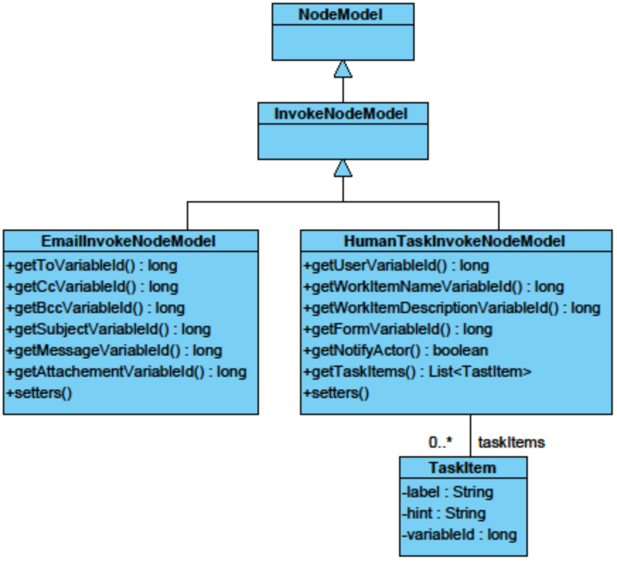
Figure 8: Class diagram of the InvokeNode models.

The EmailInvokeNodeModel Class
The EmailInvokeNodeModel class represents the email activity. It provides methods to access all attributes of a standard email: to, cc, bcc recipients, subject and body for the email text and attachments for any attached files. The values of the attributes are ids of the variable which hold the content for the attribute. The variable ids themselves are stored in the NodePropertyData class.

The HumanTaskInvokeNodeModel Class
The HumanTaskInvokeNodeModel class represents the human task activity. It provides methods to access the following attributes: Users holds the user ids of the users who will work on the work item. WorkItemName is the name of the work item, workitemDescription holds a brief description of the work item. Form is the form container for the work item. The values of the attributes are ids of the variable which hold the content for the attribute. The variable ids themselves are stored in the NodePropertyData class. Aside from those atttibutes which hold the variables ids to their contents, there are some attributes which do not hold variables: NotifyActor indicates whether the users who are assigned to the work item should be notified or not.

The TaskItem class represents the input fields of a human task. Each input field has a label and a hint, which is displayed to the user. The TaskItem also holds the id of the variable, into which the input of the user is saved.

Container Models
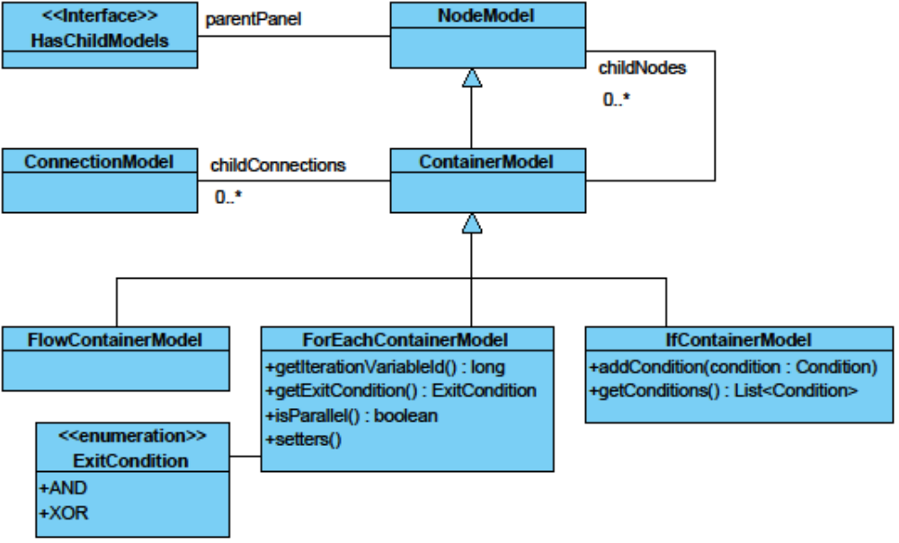
Figure 9: Class diagram of the container models.

The ContainerModel Class
The ContainerModel class is the base class for all containers of a workflow. Each container has childNodes and childConnections and implements the HasChildModels interface to provide access functions (see 2.4.2).

The FlowContainerModel Class
The FlowContainerModel class represents the model of the flow container. The model has no further properties.

The ForEachContainerModel Class
The ForEachContainerModel class represents the model of the “for each” container. The parallel attribute determines whether the child activities should be executed in a parallel or sequential way. The iterationVariable holds the id of the iteration variable. The attribute exitCondition defines whether the for each container should be regarded completed when a XOR or an AND condition is true. The values of the attributes are ids of the variable which hold the content for the attribute. The variable ids themselves are stored in the NodePropertyData class (see 2.4.6).

The IfContainerModel Class
The IfContainerModel class represents the model of the “if” container. Every “if” container has conditions. The Condition class doesn’t only model the conditional expression, it also serves as the model class for the child start connections of the IfContainer. The conditional expression itself is defined by a leftOperand, an Operator and a rightOperand. The attribute order defines the order in which the conditions are checked. For further information of the Condition class see 2.4.9.

Dialogs

Overview
This chapter describes all dialog windows and its classes which the modeling tool can display. Creating the dialogs, the widgets of the GXT framework are used. The parent class of all dialogs is the ModelingToolDialog class. A ModelingToolDialog has three main methods:
- initialize(): to create and initialize a dialog, return true, if a dialog could be correctly initialized, otherwise false
- refresh(): updates the dialog, if an underlying model has been changed
- reset(): to reset a dialog to its default values
The parent class of the ModelingToolDialog class is the class LayoutContainer, a native class of the GXT framework.

The Dialog Registry
The Dialog Registry manages the instances of all the dialogs of the Modeling Tool. The instance themselves are kept in an internal hash map. The Dialog Registry allows access to the instances. The Dialog Registry also provides methods for showing and hiding the dialogs.

Methods
- register(ModelingToolDialog dialog): registers an instance of a dialog with the Dialog Registry
- showDialog(String dialogname): displays the dialog which corresponds to the class name given as parameter, also calls the initialize method of the dialog
- hideDialog(String dialogname): hides the dialog which corresponds to the class name given as parameter, also calls the reset method of the dialog
- getDialog(String dialogname): returns the instance of the dialog

Invoker classes
The show and hide method of the dialog registry are never called directly by the method that wants to display a dialog. Instead, the invoker class of that dialog is called. The invoker class required the model of the node or container that is to be modeled by the dialog. The invoker class itself then sets the model of the dialog and calls the dialog registry.

Variable Editor
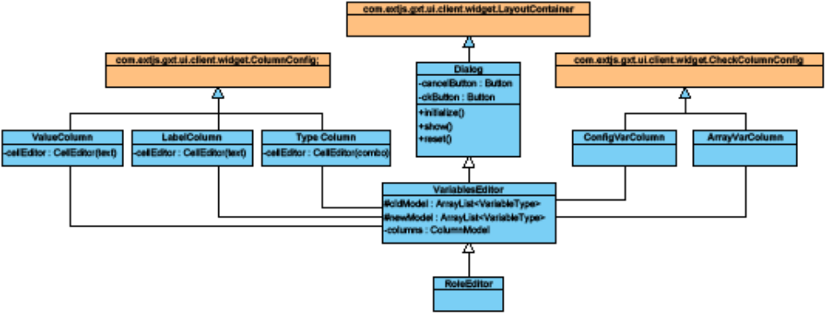
Figure 10: Class diagram of the variable editor.
The variable editor allows the tenant admin to create, edit and delete variables which will be used for the data flow of the workflow. The variable editor dialog consists of three columns. The LabelColumn allows editing the name of a variable. The TypeColumn allows selecting the type of the variable. The ConfigVarColumn allows to determine whether a variable is a configuration variable or not.
When the ok button of the Variable Editor is pressed, all variables and their changed contents will be copied to a new list of variables. This new list of variables will be pushed into the command stack.
For editing the values of a variable, there is an extra dialog, the Value Editor. For variables of the type ROLE, the Role Editor is used.

Property Windows
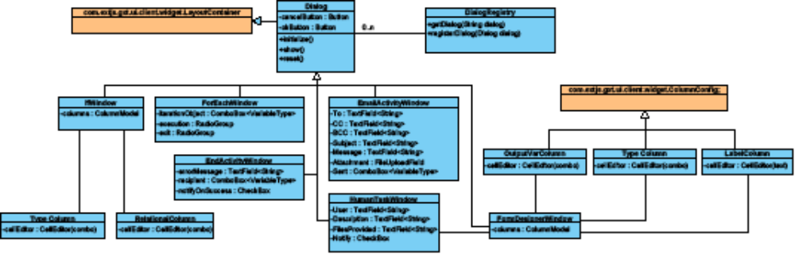
Figure 11: class diagram of the property windows
The property windows allow editing the properties of a workflow activity. Variables of the variables list can be assigned to be the input or the output variable of an activity. In addition, the “execution properties” of an activity can be set, for example, whether the for each activity should be executed in a parallel or sequential way.

Commands

The Command Stack
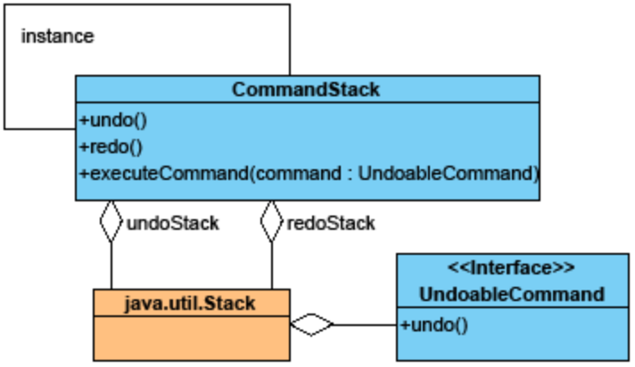
Figure 12: Class diagram of the command stack.
The command stack is responsible for executing, undoing and redoing operations. A Command is executed when it is added to the stack. If undo() is called, the supreme Command on the undo stack is undone and pushed on the redo stack. If redo() is called, the supreme Command on the redo stack is executed and pushed back to the undo stack. If a new Command is added to the undo stack, the redo stack is flushed.

Commands
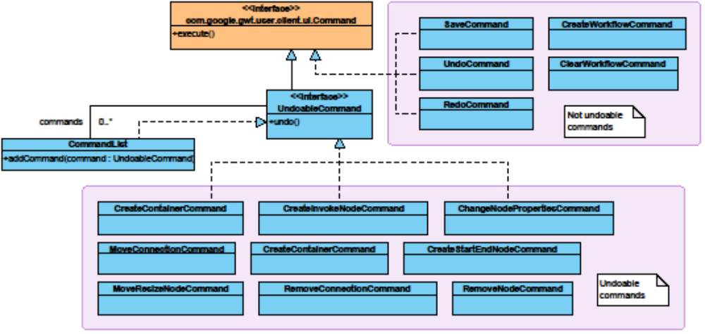
Figure 13: Class diagram of the command classes.

The UndoableCommand Interface
This interface extends the Command interface by an undo operation. The undo() operation of each command is the reverse operation of the execute() operation.

The Command Classes
Classes which are not undoable implement the Command interface directly and can’t be pushed on the CommandStack. These are the Save, Undo and Redo commands. These operations have to be put in command classes due to toolbar compatibility.

The UndoableCommand Classes
For every undoable operable change in the workflow model there is a command class implementing the UndoableCommand interface which can be filled with according parameters to describe the change and save it for undoing at later time. For convenience, the diagram above doesn’t show all possible Command classes.

External Interfaces

Loading and Storing the DWDL
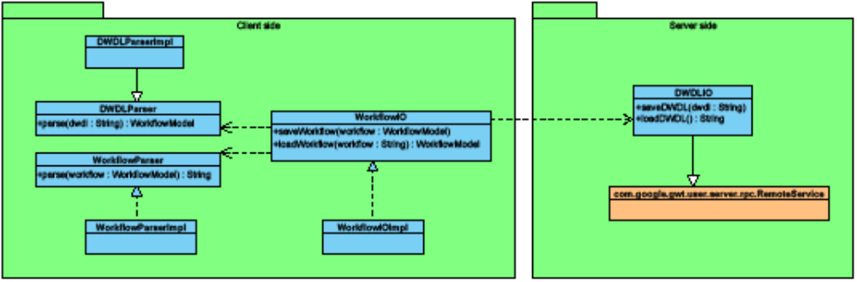
Figure 14: Schema of the loading and storing mechanism.
The loading and storing of workflows as DWDL from and into the server follows the GWT RPC mechanism. The DWDLIO class is a servlet which runs on the server. It provides the two methods for saving a DWDL into the server (saveDWDL()) and loading a DWDL from the server (loadDWDL()). These methods are called by the client WorkflowIOImpl (an implementation of WorkflowIO). Both components exchange the objects as ordinary text. The WorkflowIO uses two components for converting DWDL to a WorkflowModel object and vice versa. The DWDLParser is responsible for converting a DWDL into a WorkflowModel. The WorkflowParser is responsible for converting a WorkflowModel to a DWDL.

Embedding in the Web Portal
For the implementation of the modeling tool, the frameworks gwt-dnd and ext-gwt are used. Both frameworks are derivatives of the original GWT framework and therefore, all widgets of those frameworks are widgets of GWT classes. Since the web portal is based on the GWT framework as well, all view elements of the modeling tool can easily be embedded and can be handled as if they were elements of the web portal.

Website of Google Web Toolkit: http://code.google.com/intl/de-DE/webtoolkit/
Website of gwt-dnd: http://code.google.com/p/gwt-dnd/
Website of GXT: http://extjs.com/products/gxt/

